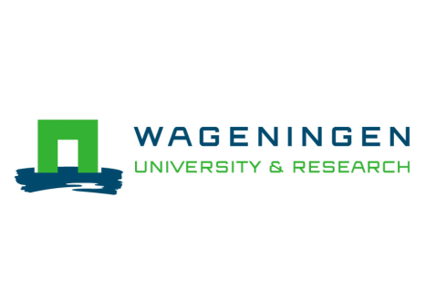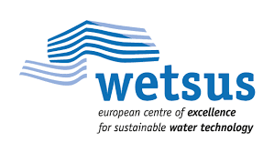

Fouling and Process Design in reverse electrodialysis: a case study with natural waters

Motivation
To include renewable energy in the energy matrix can be a challenge for many societies. Blue energy is a promising energy source that uses the controlled mixing of the salinity gradient between river and sea water to produce energy. Reverse Electrodialysis (RED) is a process that allows to harvest this energy. It uses a series of alternating anion (AEM) and cation (CEM) exchange membranes to direct ions and convert the membrane potential between the anode and cathode of a cell into electrical current, by the means of a redox reaction, as shown on the figure. Fouling of the ion exchange membranes is known as one of the most severe problems within RED applications, since it decreases the overall power output that can be harvested. For a successful RED performance it is believed that a feed water pre-treatment is necessary to inhibit fouling and enable a sustainable energy production.
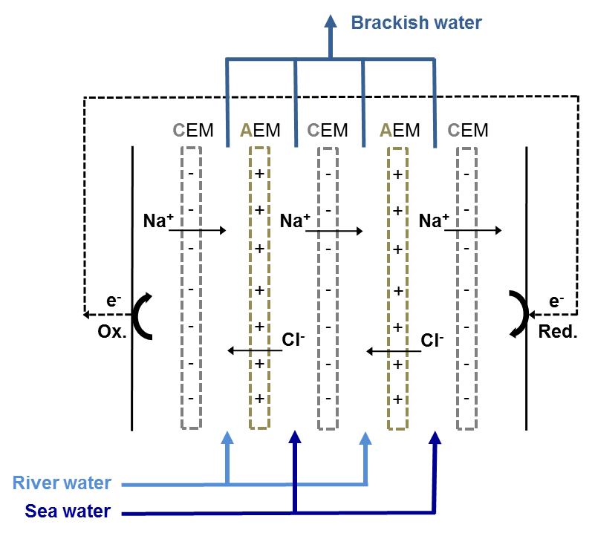
Method
The goal is to test and optimize pre-treatments for the process. Nowadays we mostly work with a sand filter, and other media that can yield a better result. The experiment consists of optimization of operational conditions of the sand filter, such as bed depth and filtration rate and seeing how this different conditions can affect the performance of stacks. Experiments are carried out in the pilot plant of REDStack in the Afsluitdijk.
Requirements
- Background in chemical/environmental engineering or other related fields
- Fluent in English, with good communication skills
- Be allowed to drive in the Netherlands and willing to drive around 35 minutes at least 2x week to the pilot plant.
Benefits and additional info
- Starting date: from July 2021, minimum duration of 5 months
- Location: Wetsus, European Centre of Excellence for Sustainable Water Technology, Leeuwarden (The Netherlands)
- Contact Barbara Vital (Barbara.vital@wetsus.nl), include CV and motivation letter.

